Non-Preemptive Scheduling

Definition
# Source: AI Source: Provided by: [Data Path: Persons Table -> ID Column: 1, Name_En Column: Motasem Essam] -> From: [ChatGPT] on [1/21/2026]
Non-Preemptive Scheduling is a CPU scheduling method where once a task starts running, it cannot be interrupted until it finishes or voluntarily gives up the CPU (e.g., waiting for I/O).

Simple Meaning
# Source: AI Source: Provided by: [Data Path: Persons Table -> ID Column: 1, Name_En Column: Motasem Essam] -> From: [ChatGPT] on [1/21/2026]
A running task keeps the CPU until it completes.
No other task can take the CPU during its execution.

How It Works
# Source: AI Source: Provided by: [Data Path: Persons Table -> ID Column: 1, Name_En Column: Motasem Essam] -> From: [ChatGPT] on [1/21/2026]
- Task A starts running
- Even if Task B (higher priority) arrives → it must wait
- Task A finishes (or blocks)
- Then the scheduler gives CPU to the next task

Examples of Non-Preemptive Scheduling
# Source: AI Source: Provided by: [Data Path: Persons Table -> ID Column: 1, Name_En Column: Motasem Essam] -> From: [ChatGPT] on [1/21/2026]
- First-Come, First-Served (FCFS)
- Shortest Job First (Non-Preemptive)
- Priority Scheduling (Non-Preemptive)

Advantages
# Source: AI Source: Provided by: [Data Path: Persons Table -> ID Column: 1, Name_En Column: Motasem Essam] -> From: [ChatGPT] on [1/21/2026]
- Simple and easy to implement
- No context switching overhead (less CPU waste)
- Predictable execution for running task

Disadvantages
# Source: AI Source: Provided by: [Data Path: Persons Table -> ID Column: 1, Name_En Column: Motasem Essam] -> From: [ChatGPT] on [1/21/2026]
- Poor response time for urgent tasks
- Long tasks can block short/important tasks (convoy effect)
- Not suitable for strict real-time systems

Preemptive vs Non-Preemptive (Quick View)
# Source: AI Source: Provided by: [Data Path: Persons Table -> ID Column: 1, Name_En Column: Motasem Essam] -> From: [ChatGPT] on [1/21/2026]
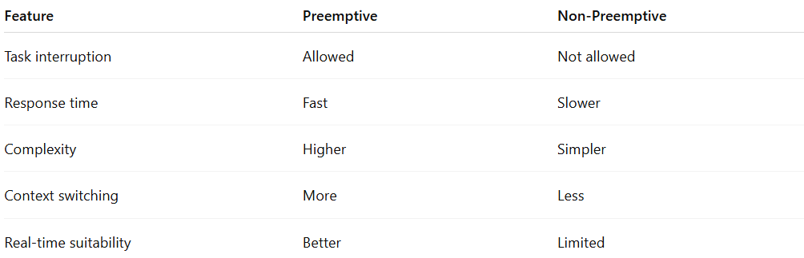
Feature | Preemptive | Non-Preemptive
Task interruption | Allowed | Not allowed
Response time | Fast | Slower
Complexity | Higher | Simpler
Context switching | More | Less
Real-time suitability | Better | Limited

